Topic 5: Commodities and Managed Futures

Chapter 19: Introduction to Commodities

- Compare commodities to capital assets.

- Capital assets such as stock and bonds pay a steam of cash flows in the form of interest or dividends.
- Commodities do not provide cash flows. So, the traditional discounted cash flow (DCF) method of asset valuation does not apply.
- CAPM cannot be applied.
- It comes down to pure supply and demand. Gold is fear and greed.
- Commodities are a distinct asset class. We can differentiate commodities from capital assets in three primary ways: valuation, the application of asset pricing models, and the global structure of commodity markets. Unlike capital assets, commodities:
- Do not pay cash flows, which means the traditional discounted cash flow method of asset valuation does not apply. Commodity prices fluctuate because of changes in supply and demand.
- Do not conform to asset pricing models, such as the CAPM.
- Trade in a global, rather than regional marketplace, making the concept of international diversification irrelevant.

2. For exposure to commodities, describe:

a. the purchasing of the underlying commodity.

- Problem is the storage cost.

b. a “pure play” investment.

- Investing in natural resource companies is considered a pure-play. An example would be investing in an OIL company.

c. commodity futures contracts and margin requirements.

- Maintenance margin

d. commodity swaps, forward contracts, commodity-linked notes, and
commodity exchange-traded funds (ETFs).

- Commodity Swaps
- Forward Contracts
- Commodity linked notes - CLNs: combine a standard interest-paying debt instrument with either a commodity future contact or an option on commodity prices.
- Commodity Exchange-traded funds (ETFs)

3. For the relationship between futures prices and spot prices:

a. calculate the futures price for an asset that pays no income.

- F = Spot e ^ RT
- Continuous

b. calculate the futures price for an asset with a known dividend yield.

- F = Spot e ^ (R-dividend yield) T

c. identify arbitrage opportunities for situations where futures prices are higher
than fair value.

- Cash-N-Carry --- SELL THE FUTURE. Carry the cash.

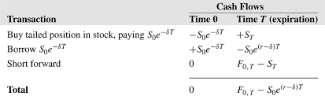

d. identify arbitrage opportunities for situations where futures prices are lower
than fair value.

- Reverse Cash-N-Carry

e. calculate the futures price for a currency contract.
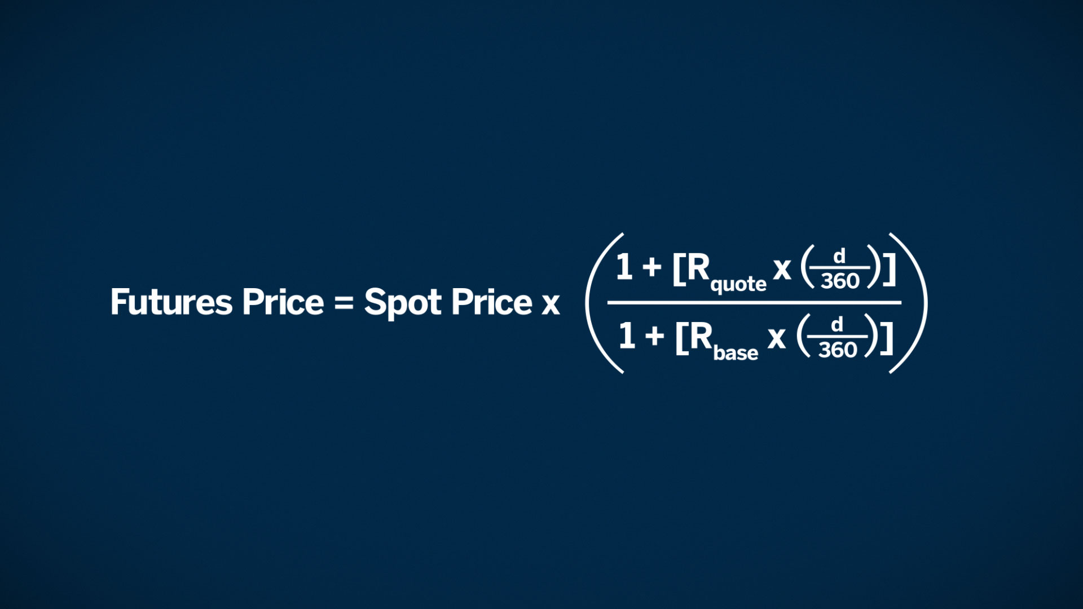

f. formulate the interest rate parity relationship (IRP).

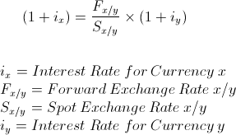

g. define storage cost.

- Cost to store the physical

h. calculate the futures price for a commodity futures contract.

- Storage costs
- Convenience yield

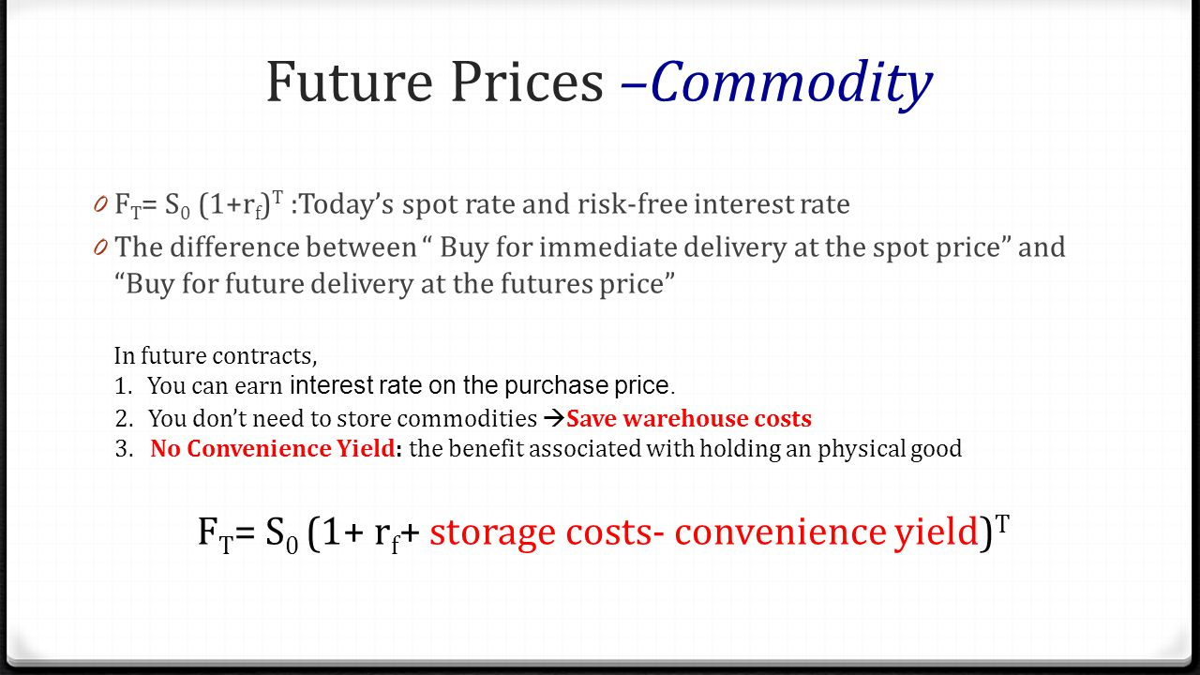

i. define convenience yield

- This is a return from holding the physical asset.
- Example: you can lend out platinum while you own the asset
- R is risk free, c is cost of storage, y is the convenience yield
- (T-t) is the time to maturity of the contract

j. identify mispricing arbitrage opportunities in the commodity markets.

- Cash and Carry – sell the future

4. For economics of the commodity markets:

a. define normal backwardation.

- Futures prices is below the expected future spot prices

b. define a contango market.

- Tango bend. The futures price is above the Spot price.

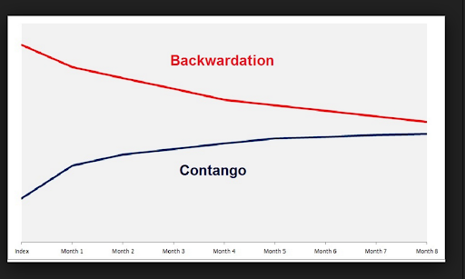

 Note: “Tango bend”

c. identify the role of futures in hedging producers’ risk.

- You can lock in a price

d. identify the role played by speculators in the commodity market.

- Speculators accept the price risk that hedges are unwilling to bear.

e. compare backwardated commodity markets to contango markets.

- Backwardated commodity markets are based on the relationship between hedgers and speculators.

f. identify the determinants of speculator profits in the commodity markets.

- Supply and demand

g. compare pricing of commodities to pricing of financial assets.

- Commodity prices depend on the short term
- private commodity pools can benefit diversified portfolios; however, the evidence does not suggest that public commodity pools can benefit diversified portfolios.

Chapter 20: Investing in Commodity Futures

- Define real assets.

- Real assets have a physical existence

2. Compare and contrast commodity and capital asset price movements with respect
to the business cycle and event risk.

- Business cycle
- Event Risk

3. Discuss the empirical evidence for the diversification potential of commodity futures added to portfolios of financial assets.
- Diversification of access. Futures offer access to certain assets that are hard to find elsewhere.
- Diversification of exposure. Get direct market exposure to underlying assets (e.g., oil or precious metals), rather than secondarily through stocks or funds.
- Diversification of risk. Futures can be an effective tool to manage risk around pre-scheduled events that have the potential to move markets
4. For Commodity Indices:

a. identify desirable characteristics.

- Total return from only long positions (i.e., investable)
- Unleveraged (i.e., no margin purchases)
- Excludes financial futures because of their linkage to financial assets

b. define an unleveraged index.

- Face values of the commodities contacts in an unleveraged index are assumed to be fully collateralized by the purchase of an equal dollar amount of US T-bills.

c. discuss the economic exposure.

- Potential of gains or losses to the purchaser of a commodity futures contact as the price of the underlying commodity changes.
- The return is magnified depending on the amount of leverage.
- Also, commodities are largely determined by supply and demand; therefore, systematic/unsystematic risk analysis is less applicable.

d. contrast the returns with those earned by managed futures accounts.

- Managed futures accounts are highly leveraged.
- Whereas the indices are passive. Long only. Commodities. Unleveraged.
- Active, long and short, commodities and financial futures, highly leverage

5. For commodity indices, identify sources of return.

- commodity price changes,
- the collateral yield (interest rate)
- and the roll yield (the spread)

f. define collateral yield.

- Collateral yield is the interest earned on the US T bills purchased to collateralize the face amount of the futures index.
- Serves as an inflation hedge as the T-bill yield is adjusted, in part, based on inflation rate changes.

g. calculate roll yield.

- Roll yield is the holding period return that results from the commodity futures term structure. Will converge upon maturity.
- Roll yield is a type of return in commodity futures investing. It is driven by the difference in the price of shorter-dated, closer to maturity commodity contracts and their longer-dated counterparts.
- Roll yields can either be positive or negative, depending upon whether the market is in backwardation or contango.
- Roll return offers the added advantage of providing an insight into the expected price movement of a commodity futures contract, be it a drop in prices from the contango or the opposite in the case of backwardation.
- Change in the Future’s Price = $100 – $95 = $5
- Change in the Spot Price = $100 – $100 = $0
- Roll Yield = $5 – $0 = $5

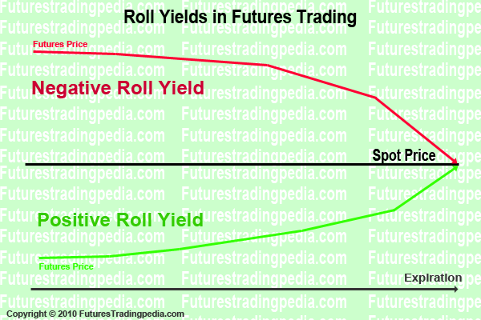 Note: “Roll yield”

h. distinguish between circumstances resulting in positive roll yield and those resulting in negative roll yield.

- Positive roll yield (+) is a backwardated market.
- Negative roll yield (-) is produced in a contango market.

5. For the Goldman Sachs Commodity Index (GSCI):

a. identify the main characteristics.
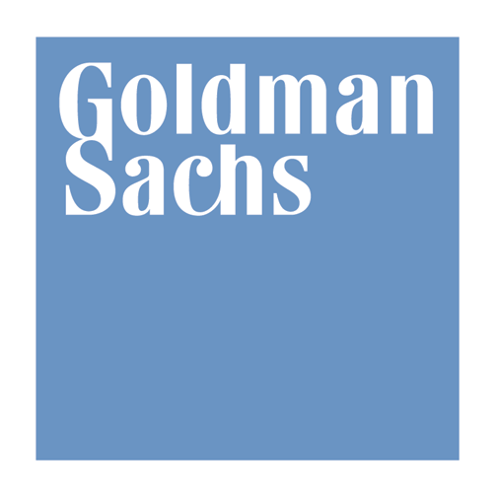
Event risk is good. The most common event risk is an unexpected drop in supply that increases commodity prices. Such events lead to positively skewed price distributions.

- This is a long only, tradable index for physical commodity futures contracts.
- It was created in 1991 and was constructed for periods starting in 1970.
- Futures contracts based on the GSCI can be purchased.
- The index is comprised of the shortest maturity contact for each of the 24 physical commodities contacts included in the index.

b. describe the weighting methodology.
- The GSCI is production-value weighted, using exogenous economic data to reflect the importance of each component of the global economy.
- The asset weights of the indices are set at the beginning of each year and change throughout the year based on commodity price fluctuations.
- Commodities with price gains will become a larger part of the index as the year progresses.

c. identify the five groups of real assets represented for GSCI.
- Metals (gold, silver)
- Industrial metals (copper, platinum)
- Livestock
- Agriculture
- Energy
Energy makes up over 70% of the index

d. identify the main characteristics of the GSCI historical return distribution.
- Positively skewed. With fat tails (leptokurtic).
- Therefore, indication that the exposure to event risk is beneficial to GSCI returns.

For the Dow Jones-AIG Commodity Index (DJ-AIGCI):

a. identify the main characteristics.

- The DJ-AIGCI is a long only, diversified index of 19 physical commodities.
- Long only
- Event risk is good. Remember – events for commodities are positively skewed.

b. identify the components.
- Energy
- Precious metals,
- Industrial metals
- Grains
- Livestock
- Soft commodities (coffee, cotton, and sugar) (this is different than GSCI)

c. describe the weighting methodology.
- DJ-AIGCI index is weighted primarily by the trading volume of the futures contacts and secondarily on production.
- No group comprises more than 33% of the index and that each commodity must represent at least 2% of the index.

d. identify the main characteristics of the historical return distribution.
- For the DJ-AIGCI it is described as being positively skewed and slightly leptokurtic, therefore indication that the exposure to event risk is beneficial to DJ-AIG CI returns

7. Describe the Reuters/Jefferies Commodity Research Bureau (CRB) Index.

- Naïve index
- Equally weights each of the 19 physical commodities that comprised the index.
- Event risk is pretty good, but not great
- Positively skewed, but platykurtic
- It has the lowest average return of the four indices
- It currently is made up of 19 commodities Petroleum based products (based on their importance to global trade, always make up 33% of the weightings)

8. For the Mount Lucas Management Index (MLMI):

a. identify the main characteristics.

- Event risk NOT good
- Created in 1988.
- It’s an investable index
- Has an advantage of symmetry
- Lower Volatility compared to the other future indices
- Allows for both long or short positions in physical commodity, financial, and currency futures.
- A 12 month moving average determines if the index should be long or short in the futures contract.
- Rebalanced monthly

b. identify the components.
- MLMI invests in 22 futures contacts in three categories including commodities, financials, and currencies.

c. describe the weighting methodology.
- An equally weighted index

d. identify the main characteristics of the historical return distribution.
- It is described as being negatively skewed. So, event risk will be BAD.
- Like the others, it is Leptokurtic
- It has the highest Return given the level of Risk

Chapter 21: Commodity Futures in a Portfolio context

- Explain how real assets such as commodity futures can hedge against the decline
of stocks and bonds prices in an inflationary environment.

- The correlation between the four commodity futures indeces and inflation is positive. Whereas the correlation between inflation and stocks and bonds is negative.

2. Explain why commodities are perceived to be a better inflationary hedging tool
than Treasury inflation protected securities (TIPS).

- TIPS are adjusted based on inflation as measure by the Consumer Price Index (CPI).
- TIPS are U.S. government bonds.
- The use of commodities, however, provides better protection against inflation because their values will actually increase during periods of high inflation.
- TIPS only preserve capital while commodities can make you money.

3. Identify why international stocks generally do not offer inflationary protection for
a U.S. portfolio of stocks and bonds.

- International stocks are also negatively correlated to inflation

4. Compare the risk and return characteristics of commodity indices to traditional broad market indices.

- GSCI hast the highest volatility of all indices and benchmarks.
- Volatility and return performance of the CRB was low.

5. Define the efficient frontier.

- Graph of the risk/return profile

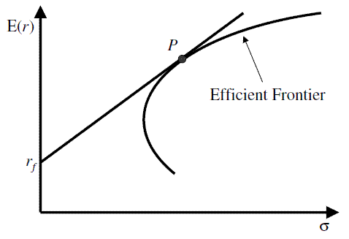

6. Identify how adding a passive commodity index to a portfolio of stocks and bonds
changes the efficient frontier.

- It will produce a more efficient portfolio. UP and to the LEFT

7. Compare the effects of adding the Goldman Sachs Commodity Index (GSCI), the
Dow Jones-AIG Commodity Index (DJ-AIGCI), and the Mount Lucas
Management Index (MLMI) to a portfolio of stocks and bonds.

- GSCI, DJ-AIGCI, and MLMI) to a portfolio of stocks and bonds produces a more efficient set of portfolios.
- Risk averse investors will benefit most from the inclusion of commodity futures in their portfolios.

8. Identify how extreme market events can affect the return correlation of equity
instruments.

- Empirical studies have reported an increased correlation among equity markets from different countries during periods of economic downturns.
- For example, the impact of an oil price shock will affect all economies and the equity values on those economies. These higher correlations resuce the diversification benefits of adding international equities to a portfolio.”

Reasons are as follows:
- Treaties
- An increase in multinational companies
- Increases in capital flows between countries
- Greater individual investor access to foreign investments

9. Identify the potential of downside risk protection offered by commodities when added to portfolios of stocks and bonds.

- It improves downside risk protection
- DJ-AIGCI has the highest Sharpe ratio and provides the most downside protection

Chapter 22: Managed Futures

Define:
a. commodity pool.

- A collection of investors who combine their funds to invest in the commodities futures market. Commodity pools are a subset of the hedge fund market. Commodity pools are managed by a general partner, which generally must register with the CFTC and the NFA.

b. public commodity pool.

- Are available to the general public.

c. private commodity pool.

- These pools avoid SEC registration
- Private commodity pools do not have to register with the SEC, but they may have to report to the CFTC. Relative to public commodity pools, private commodity pools have lower brokerage fees and more investment flexibility. Public commodity pools must register with the SEC and also must file reports with the CFTC.

2. Define the relationship between commodity pool operators (CPOs) and
Commodity trading advisors (CTAs).

- CPOs are the general partners in a commodity pool.
- Both public and private CPOs typically hire professional money managers called Commodity Trading Advisors to manage the funds in the commodity pool.
- However, in some cases the CPO and the CTA are the same entity.
- CTAs are responsible for advising managed accounts and pooled investment vehicles, such as commodity pools.
- CTAs regularly advise investors about the value of commodity futures or options, or the advisability of trading in commodity futures or options.
- A commodity pool describes an investment vehicle in which money contributed by a number of persons, investors, or entities is combined for the purpose of trading futures, swaps, contracts, or commodity options with limited liability.
- CPOs are the organizations managing commodity pools.
- A CPO solicits or accepts funds, securities or property from prospective investors in the commodity pool.
- CPOs can make trading decisions on behalf of the pool, or they can retain the services of a CTA to do so.
- Investments in commodity pools serve to diversify portfolios, helping to enhance portfolio returns and historically reduce volatility for investors.
- Public commodity pools provide retail investors access to products that were generally only available to large investors.
  - CPOs are formally defined under Section 1a(5) of the CEA, 7 U.S.C. § 1a(5)

3. Describe the history of organized futures trading in the U.S.

- CBOT was formed in 1848. CME was created shortly thereafter. The volatility of the underlying assets created the need for these exchanges.

4. Identify standard fees charged by CTAs and CPOs.

- The standard fees charged by CPO and CTA are a 2% management fee and a 20% incentive fee, or simply 2 and 20. However, management fees can range from 0% to 3%, and incentive fees can range from 10% to 35%

5. For the Commodity Exchange Act (CEA), identify the:

- standards established by the Act.

- The Act Created the CFTC in 1974
- CFTC created the NFA in 1982
- Traders and brokers are required to report their activity on the exchange to the CFTC
- Each exchange is required to disclose information regarding the previous day’s trades
- Record keeping: a daily record for each customer’s trades must be maintained

- registration requirements established by the Act.

- CPOs and CTAs are required to register with the CFTC and the National Futures Association (NFA).
- CPOs and CTAs are required to also meet continuing education requirements.
- The CPO can also be registered as the CTA



c. role of the National Futures Association (NFA) as established by the Act.

- The role of the NFA. An organization to self-regulate the managed futures industry.



6. Discuss the empirical evidence on the portfolio performance benefits of
Investment in CTAs, private and public commodity pools.

- The results from the studies analyzing performance persistency (or consistency) are mixed, therefore leaving this as an unresolved issue.
- Selecting CTAs based on prior performance will be about the same as a naïve strategy.

7. Describe how one can detect the level of skill of a CTA by using a naïve
benchmark.

- A CTA with positive skewness indicates the CTA was able to add value for investors.

8. Describe conclusions that can be made by analyzing historic return distributions
for different managed futures indices.

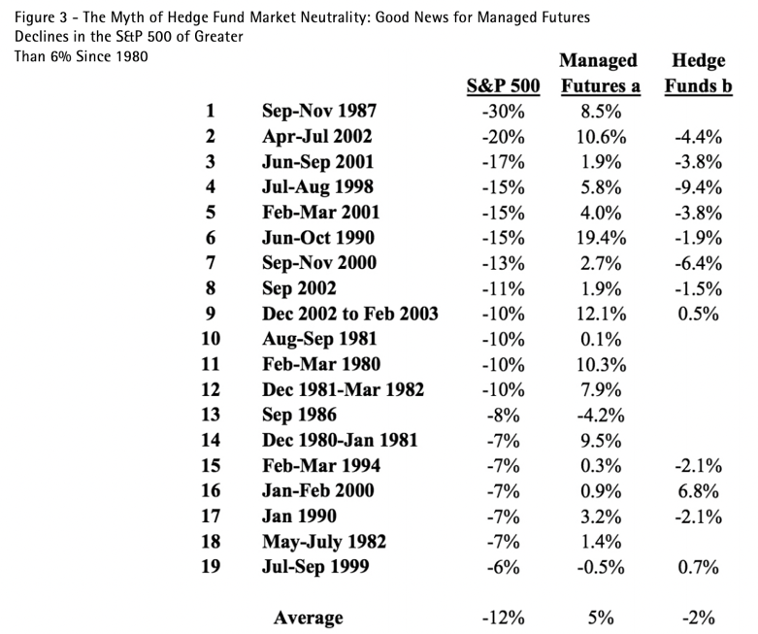

9. Compare the effects of adding managed futures versus adding passive
Commodities to a portfolio of stocks and bonds.

- Inclusion of a managed CTA index or the MLM to a portfolio of US stocks and bonds did not provide diversification benefits.
- However, note that the addition of the Currency CTA index of the Diversified Trader CTA Index did slightly increase the Sharpe ratio.

10. Identify the potential downside of risk protection offered by managed futures for portfolios of stocks and bonds.

- Commodities work in a reverse fashion (event risk is to the upside).
- The MLM provided the most downside risk protection.

